Составить слово и построить дерево:

G=(Vn, Vt, P, S), Vn={S,A,B,C,}, Vt={ a,b,c,d},

 P={

1. S→aABd
2. S→aBa
3. S→AC
4. S→Ba
5. S→Cc
6. A→bA
7. A→b
8. A→CdC
9. A→C
10. B→SB
11. B→C
12. C→a
13. C→Bda}.

S →2→ aBa →10→aSBa→11→aSCa→12→aSaa→5→aCcaa→12→aacaa

S →1→ aABd →11→aACd→13→aABdad→11→aACdad→12→aAadad →7→abadad

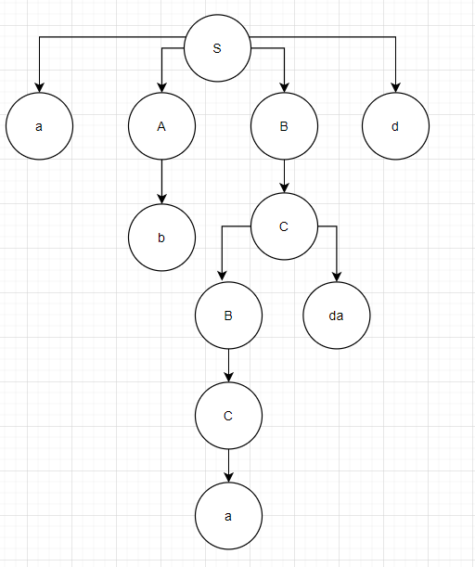

S →2→ aBa →11→aCa→12→aaa

G=(Vn, Vt, P, S), Vn={S,A,B,C}, Vt={ a,b,d}, P={

* 1.S→aSA
* 2.S→ab
* 3.A→ABab
* 4.A→Aa
* 5.A→aa
* 6.B→BaBC
* 7.B→ba
* 8.B→d
* 9.C→AC
* 10.C→ab
* 11.C→AB}

S → 1 →aSA →5→aSaa→2→aabaa

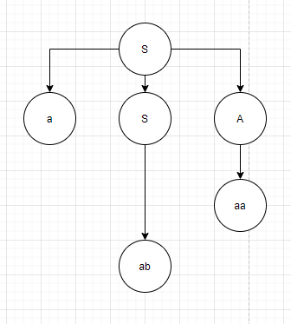

G=(Vn, Vt, P, S), Vn={S,A,B,F}, Vt={ a,b,d}, P={

1. S→aAF
2. S→aB
3. S→AF
4. S→Aa
5. S→F
6. A→fA
7. A→b
8. A→FF
9. A→B
10. 10.B→A
11. B→b
12. F →d
13. F→a

}.

S→1→aAF→12→aAd→8→aFFd→12→aFdd→13→aadd

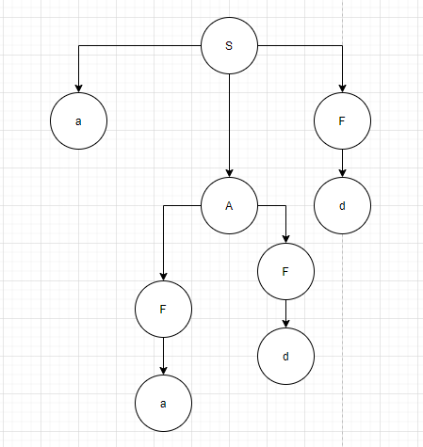

S→1→aAF→12→aAd→7→abd

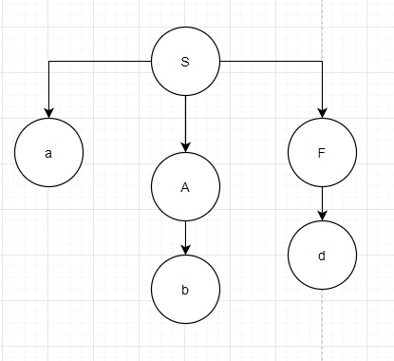

G=(Vn, Vt, P, S), Vn={S,A,B,F}, Vt={ a,b,d}, P={

1. S→aAF
2. S→aB
3. S→AF
4. S→Aa
5. S→F
6. A→fA
7. A→b
8. A→FF
9. A→B
10. 10.B→A
11. B→b
12. F →d
13. F→a

}

S → 1 → aAF → 12 → aAa → 9→ aBa → 10 →aba

Избавиться от эпсилон продукций

|  |  |
| --- | --- |
| P={  1.S→DAB  2. A→BtB  3.A→ɛ  4.B→DD  5. B→ɛ  6. D→AA  7.D→b  8. D→c  }. | N1  = {A, B}  N2 = {A, B, D}  N3 = {A, B,D S}  P={   1. M→ ɛ 2. M→S 3. S→DAB 4. S→DA 5. S→DB 6. S→AB 7. S→A 8. S→B 9. S→D 10. A→BtB 11. A→Bt 12. A→tB 13. A→t 14. B→DD 15. B→D 16. D→AA 17. D→A 18. D→b 19. D→c   }. |
| P={  1.M→BAF  2. A→BfB  3.A→ɛ  4.B→FF  5. B→ɛ  6. F→AA  7.F→f  8. B→m  } | N0 {A, B}  N1 {A, B,F}  N2 {A, B, F, M}  N3 {A, B, F, M}  P={  Z →ɛ  Z→M  M→BAF  M→BA  M→BF  M→AF  M→B  M→A  M→F  A→BfB  A→Bf  A→fB  A→f  B→FF  B→F  F→AA  F→A  F→f  B→m  } |
| P={  1.S→DAB  2. A→BtB  3.A→ɛ 4.  B→DD  5. B→ɛ  6. D→AA  7.D→b  8. D→c} |  |
| G=(Vn, Vt, P, S), Vn={S,A,B,C,D}, Vt={ a, b, c, d,}, P={  1. S→BbAa  2. A→bc  3. B→bCC  4. B→DaB  5. C→abB  6. C→DD  7. C→ad  8. D→aDaB  9. D→c  }. | Pr0 = {C, D, A}  Pr1 = {C, D, A, B}  Pr2 = {C, D, A, B, S}  Pr3 = {C, D, A, B, S}  Все нетерминалы грамматики продуктивны  Нерподуктивных символов нет  Ac0 = {S}  Ac1 = {S,A,B}  Ac2 = {S,A,B, C, D}  Ac3 = {S,A,B, C, D}  Недостижимых символов нет |
| G=(Vn, Vt, P, S), Vn={S,A,B,C}, Vt={ a, c, d}, P={   1. S→aABd 2. S→aBa 3. S→AC 4. S→Ba 5. S→Cc 6. A→bA 7. A→b 8. A→CdC 9. A →a 10. A→Bda 11. B→SB 12. B→a 13. B→Bda 14. C →a 15. C→Bda   } |  |
| G=(Vn, Vt, P, S), Vn={S,A,L,M}, Vt={ a,b,d,f}, P={  1. S→LAM  2. A→dLf  3. L→bab  4. L→b  5. L→bA  6. M→aaM  7. M→aa  }. | G=(Vn, Vt, P, S), Vn={S,A,L,M}, Vt={ a,b,d,f}, P={   1. S→LAM 2. A→dLf 3. L→bX 4. X→ab 5. X→ɛ 6. X→bA 7. M→aaY 8. Y→ɛ 9. Y→M   }. |
| G=(Vn, Vt, P, S), Vn={S,A,B,M}, Vt={ a, b, d}, P={  1. S→aMA  2. S→Md  3. S→CA  4. S→M  5. S→A  6. A→bA  7. A→b  8. A→CdC  9. A→C  10.B→SM  11. M→b  12. C →a  13. C →Mda  } | G=(Vn, Vt, P, S), Vn={S,A,B,M}, Vt={ a, b, d}, P={   1. S→aMA 2. S→Md 3. S→CA 4. S→ b 5. S→bA 6. S→b 7. S→CdC 8. S →a 9. S →Mda 10. S→bA 11. A→b 12. A→CdC 13. A →a 14. A →Mda 15. B→SM 16. M→b 17. C →a 18. C →Mda   } |
| G=(Vn, Vt, P, S), Vn={S,A,L,M}, Vt={ a,b,d,f}, P={  1. S→LAM  2. A→dLf  3. L→bab  4. L→b  5. L→bA  6. M→aaM  7. M→aa} |  |
| G=(Vn, Vt, P, S), Vn={S,A,BC,D}, Vt={ a,c, d}, P={  1.S→aBd  2.S→aBAC  3.A→Bc  4.A→Da  5.A→ε  6.C→CdA  7.C→CBe  8.C→A  9. D→aA  10.D→a  11.D→ε  } | N0 = {A,D}  N1 = {A, D, C}  N2 = {A, D, C}  G=(Vn, Vt, P, S), Vn={S,A,BC,D}, Vt={ a,c, d}, P={   1. S→aBd 2. S→aBAC 3. S→aBA 4. S→aBC 5. S→aB 6. A→Bc 7. A→Da 8. A→a 9. C→CdA 10. C→dA 11. C→Cd 12. C→d 13. C→CBe 14. C→Be 15. C→A 16. D→aA 17. D→a   } |
| G=(Vn, Vt, P, S), Vn={S,B,C,D,F, K }, Vt={ a, b, c }, P={  1. S→aBa  2. B→Sb  3. B→bCC  4. B→DaB  5. C→abb  6. C→DD  7. K→aC  8. D→aDB  9. D→cD  10. F→cF  } | Pr0 = {C,K}  Pr1= {C,K,B}  Pr2= {C,K,B,S}  Pr3= {C,K,B,S}  Npr={D, F}  G=(Vn, Vt, P, S), Vn={S,B,C,D,F, K }, Vt={ a, b, c }, P={  1. S→aBa  2. B→Sb  3. B→bCC  4. B→DaB  5. C→abb  6. C→DD  7. K→aC  }  AC0 = {S}  AC1 = {S,B}  AC1 = {S,B,C}  AC1 = {S,B,C}  NAC = {K}  G=(Vn, Vt, P, S), Vn={S,B,C,D,F, K }, Vt={ a, b, c }, P={  1. S→aBa  2. B→Sb  3. B→bCC  4. B→DaB  5. C→abb  6. C→DD  } |
| G=(Vn, Vt, P, S), Vn={S,A,BC,D}, Vt={ a,c, d},  P={  **1.S→aBd**  **2.S→aBAC**  **3.A→Bc**  **4.A→Da**  **5.A→ε**  **6.C→CdA**  **7.C→CBe**  **8.C→A**  **9. D→aA**  **10.D→a**  **11.D→ε**  }. | N0 = {D, A}  N1 = {A,D,C}  N2 = {A,D,C}  G=(Vn, Vt, P, S), Vn={S,A,BC,D}, Vt={ a,c, d},  P={   1. **S→aBd** 2. **S→aBAC** 3. **A→Bc** 4. **A→Da** 5. **C→CdA** 6. **C→CBe** 7. **C→A** 8. **D→aA** 9. **D→a**   }. |
| G=(Vn, Vt, P, S), Vn={S,A, B,C,D,E, M }, Vt={ a, b, c, d, e}, P={  **1. S→AMC**  **2. S→DSb**  **3. A→aba**  **4. A→aM**  **5.  M→bCB**  **6. M→bC**  **7. C→bCAE**  **8. C→cA**  **9. D→dD**  **10. D→d**  **11. E→e**  **12. E→Ee**  } | PR0 ={A,D,E}  PR1 ={A,D,E,C}  PR2 ={A,D,E,C,M}  PR3 ={A,D,E,C,M,S}  PR4 ={A,D,E,C,M,S}  N ={B}  G=(Vn, Vt, P, S), Vn={S,A, C,D,E, M }, Vt={ a, b, c, d, e}, P={  **1. S→AMC**  **2. S→DSb**  **3. A→aba**  **4. A→aM**  **6. M→bC**  **7. C→bCAE**  **8. C→cA**  **9. D→dD**  **10. D→d**  **11. E→e**  **12. E→Ee**  }  AC0 = {S}  AC0 = {S,A,M,C,D}  AC0 = {S,A,M,C,D, E}  Недостижимых символов нет |
| G=(Vn, Vt, P, R), Vn={R, L, B}, Vt={ a,b,d,m}, P={   1. **R→LB** 2. **L→dLf** 3. **L→dLma** 4. **L→d** 5. **L→b** 6. **B→bmaB** 7. **B→bma**   } | G=(Vn, Vt, P, R), Vn={R, L, B}, Vt={ a,b,d,m}, P={   1. **R→LB** 2. **L→dX** 3. **X →ɛ** 4. **X→Lf** 5. **X→Lma** 6. **L→b** 7. **B→bmaZ** 8. **Z→B** 9. **Z→ɛ**   } |
| G=(Vn, Vt, P, S), Vn={S,B,C,D, M}, Vt={ a,c, d}, P={  1. S→MBd  2. S→aBC  3. M→BMc  4. M→MD  5. M→ε  6. B→MC  7. C→M  8. C→d  9. D→aD  10. D→ε  } | N0 = {M, D}  N1 = {M, D, C}  N2 = {M, D, C, B}  N3 = {M, D, C, B}  G=(Vn, Vt, P, S), Vn={S,B,C,D, M}, Vt={ a,c, d}, P={   1. S→MBd 2. S→Md 3. S→Bd 4. S→d 5. S→aBC 6. S→aC 7. S→aB 8. S→a 9. M→BMc 10. M→Mc 11. M→Bc 12. M→c 13. M→MD 14. M→D 15. M→M 16. B→MC 17. B→M 18. B→C 19. C→M 20. C→d 21. D→aD 22. D→a   } |

G=(Vn, Vt, P, E), Vt={a, b, c, d, +, -, *, /, (, )}, Vn={E,T,F}, P={

1. E→T

2. E→E+T

3. E→E-T

4. T→F

5. T→T*F

6. T→T/F

7. F→(E)

8. F→a

9.F→b

10. F→c

11. F→d

**a+b*(a-b)/d-c+a*d*c**

**E**

**E+T**

**E+T+T**

**T+T+T**

**F+T+T**

**a+T+T**

**a+T/F+T**

**a+T*F/F+T**

**a+F*F/F+T**

**a+b*F/F+T**

**a+b*(E)/F+T**

**a+b*(E-T)/F+T**

(a*b-c)*d+b/(a+c)-d

E→3

E-T→2

E+T-T→1

T+T-T→4

F+T-T→7

(E)+T-T→3

(E-T)+T-T→1

(T-T)+T-T→5

(T*F-T)+T-T→4

(F*F-T)+T-T→8

(a*F-T)+T-T→9

(a*b-T)+T-T→4

(a*b-F)+T-T→10

(a*b-c)+T-T→6

(a*b-c)+T/F-T→4

(a*b-c)+F/F-T→9

(a*b-c)+b/F-T→7

(a*b-c)+b/(E)-T→2

(a*b-c)+b/(E+T)-T→1

(a*b-c)+b/(T+T)-T→4

(a*b-c)+b/(F+T)-T→8

(a*b-c)+b/(a+T)-T→4

(a*b-c)+b/(a+F)-T→10

(a*b-c)+b/(a+c)-T→4

(a*b-c)+b/(a+c)-F→11

(a*b-c)+b/(a+c)-d

(a+b*c)/d+c+a*c

E→2

E+T→2

E+T+T→1

T+T+T→6

T/F+T+T→4

F/F+T+T→7

(E)/F+T+T→2

(E+T)/F+T+T→1

(T+T)/F+T+T→4

(F+T)/F+T+T→8

(a+T)/F+T+T→5

(a+T*F)/F+T+T→4

(a+F*F)/F+T+T→9

(a+b*F)/F+T+T→10

(a+b*c)/F+T+T→11

(a+b*c)/d+T+T→4

(a+b*c)/d+F+T→10

(a+b*c)/d+c+T→5

(a+b*c)/d+c+T*F→4

(a+b*c)/d+c+F*F→8

(a+b*c)/d+c+a*F→11

(a+b*c)/d+c+a*c

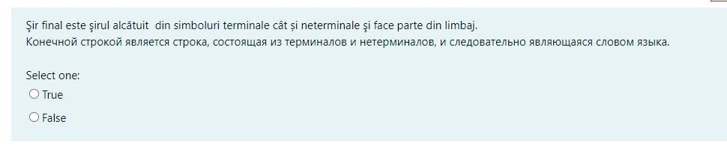

True

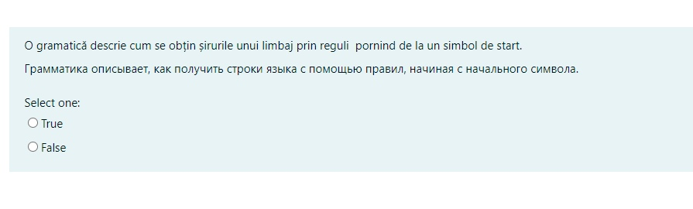

True

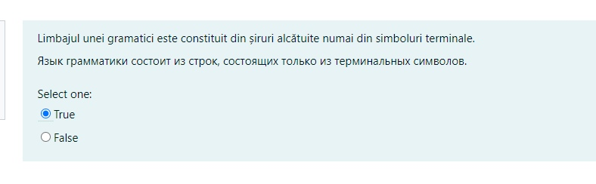

True

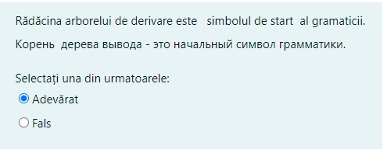

True

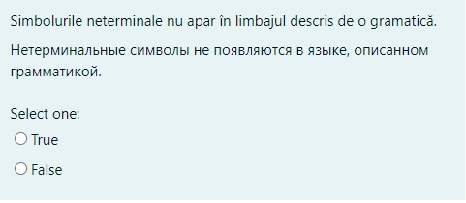

True

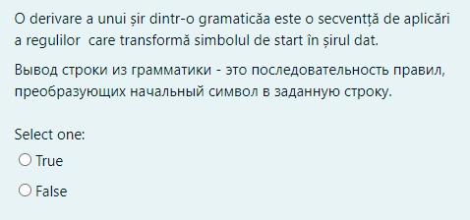

True

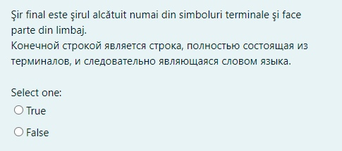

True

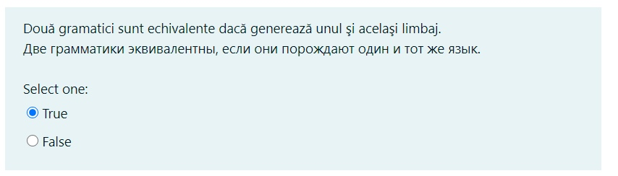

True

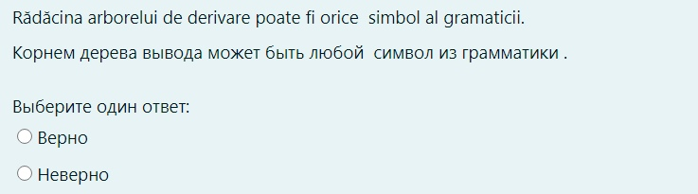

False